Engineering math assignment
Problem 1:
An electric utility is interested in developing a model relating peak hour demand (y in kilowatts) to total monthly energy usage during the month (x, in kilowatt hours). Data for 50 residential customers are shown in the following table.
- Draw a scatter diagram of y versus x. Does the scatter diagram exhibit a linear relationship between x and y?
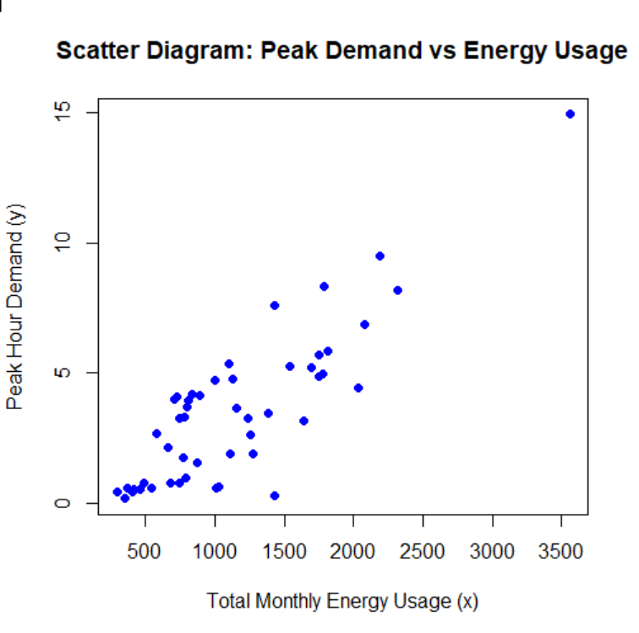
The scatter diagram does not exhibit a clear linear relationship between x and y
- Find the regression line with peak hour demand as the dependent variable and total monthly energy usage as independent variable. Give a brief interpretation of the regression coefficients.
Call:
lm(formula = y ~ x)

Residuals:
Min 1Q Median 3Q Max
-4.3259 -0.9492 -0.2181 1.3378 2.9672

Coefficients:
Estimate Std. Error t value Pr(>|t|)
(Intercept) -0.8819274 0.4521244 -1.951 0.057 .
x 0.0038479 0.0003483 11.047 8.81e-15 ***
---
Signif. codes: 0 ‘***’ 0.001 ‘**’ 0.01 ‘*’ 0.05 ‘.’ 0.1 ‘ ’ 1

Residual standard error: 1.562 on 48 degrees of freedom
Multiple R-squared: 0.7177, Adjusted R-squared: 0.7118
F-statistic: 122 on 1 and 48 DF, p-value: 8.808e-15

The Regression Equation
From the Coefficients section of the output:
- Intercept: -0.8819
this represents the predicted peak hour demand when total monthly energy usage is 0 kWh. The result thus suggests that the linear model is only valid within the range of the observed data and should not be extrapolated to zero usage
- Slope: 0.0038
It indicates that for every 1 kWh increase in total monthly energy usage, the peak hour demand increases by approximately 0.0038 kW
- Plot the regression line on the scatter diagram of part (a).
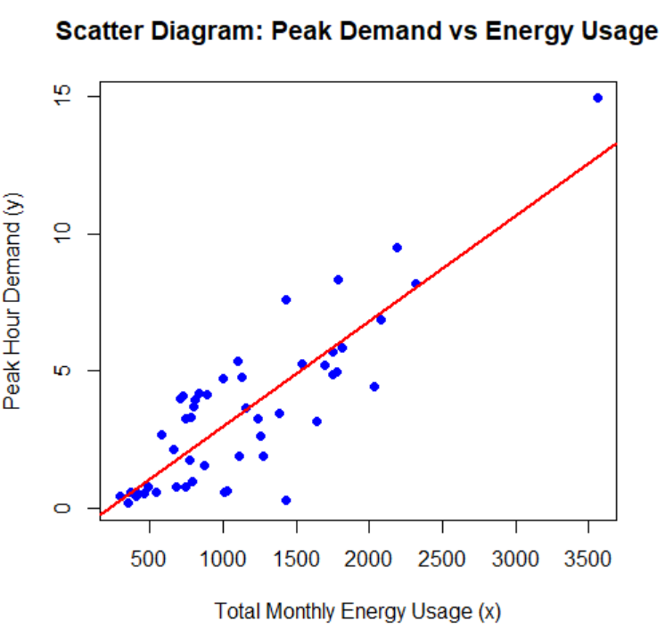
- Predict the peak hour demand for 1000 kilowatt hours of total monthly energy usage.
Predicted Peak Hour Demand for 1000 kWh: 2.965928
Problem 2:
In an article in IEEE Transactions on Instrumentation and Measurement (2001, Vol. 50, pp. 986–990), researchers studied the effects of reducing current draw in a magnetic core by electronic means. They measured the current in a magnetic winding with and without the electronics in a paired experiment. Data for the case without electronics are provided in the following table.
Questions:
  - Graph the data and fit a regression line to predict current without electronics to supply voltage.
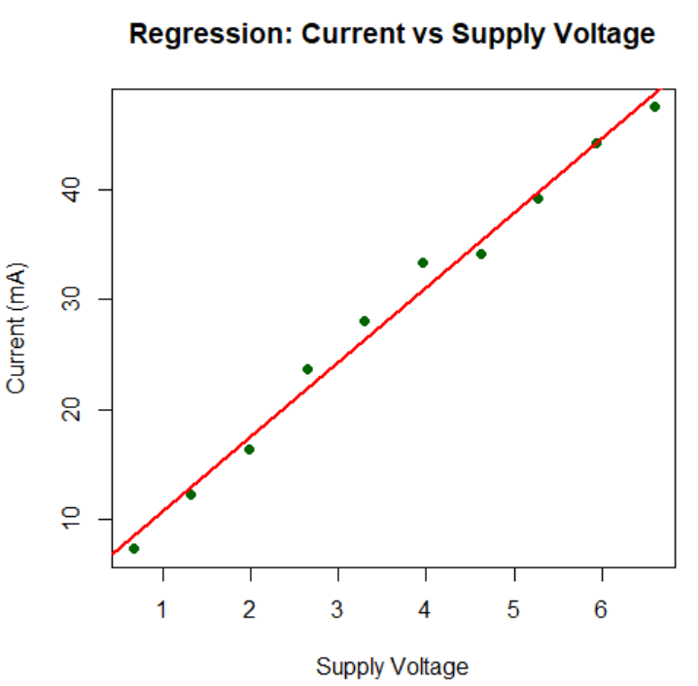
Estimated Current without Supply Voltage is 3mA
  - Estimate the correlation coefficient
Correlation Coefficient (r): 0.9943178
  - Compute at 95% the confidence interval for correlation coefficient.
95% Confidence Interval: 0.9752376 0.9987057
  - Use the model in part (a) to estimate the supply voltage for 30mA current without electronics.
Estimated Supply Voltage for 30mA: 3.836878 = around 4

